Safe Operating Procedure

Standard Washroom Cleaning and Disinfection
Chemicals  Chemicals to be used while cleaning:  - ECOLAB Peroxide Multi Surface Cleaner and Disinfectant  - Dilution: 6 fl. oz/gallon  - Contact time: 1 minute  - Do not mix with bleach or other chlorinated products – will cause chlorine gas.  - ECOLAB Neutral Disinfectant Cleaner  - Dilution: 2 fl. oz/gallon  - Contact time: 10 minutes  - ECOLAB Sanitizing Wash 'n Walk  HAZARDS  \  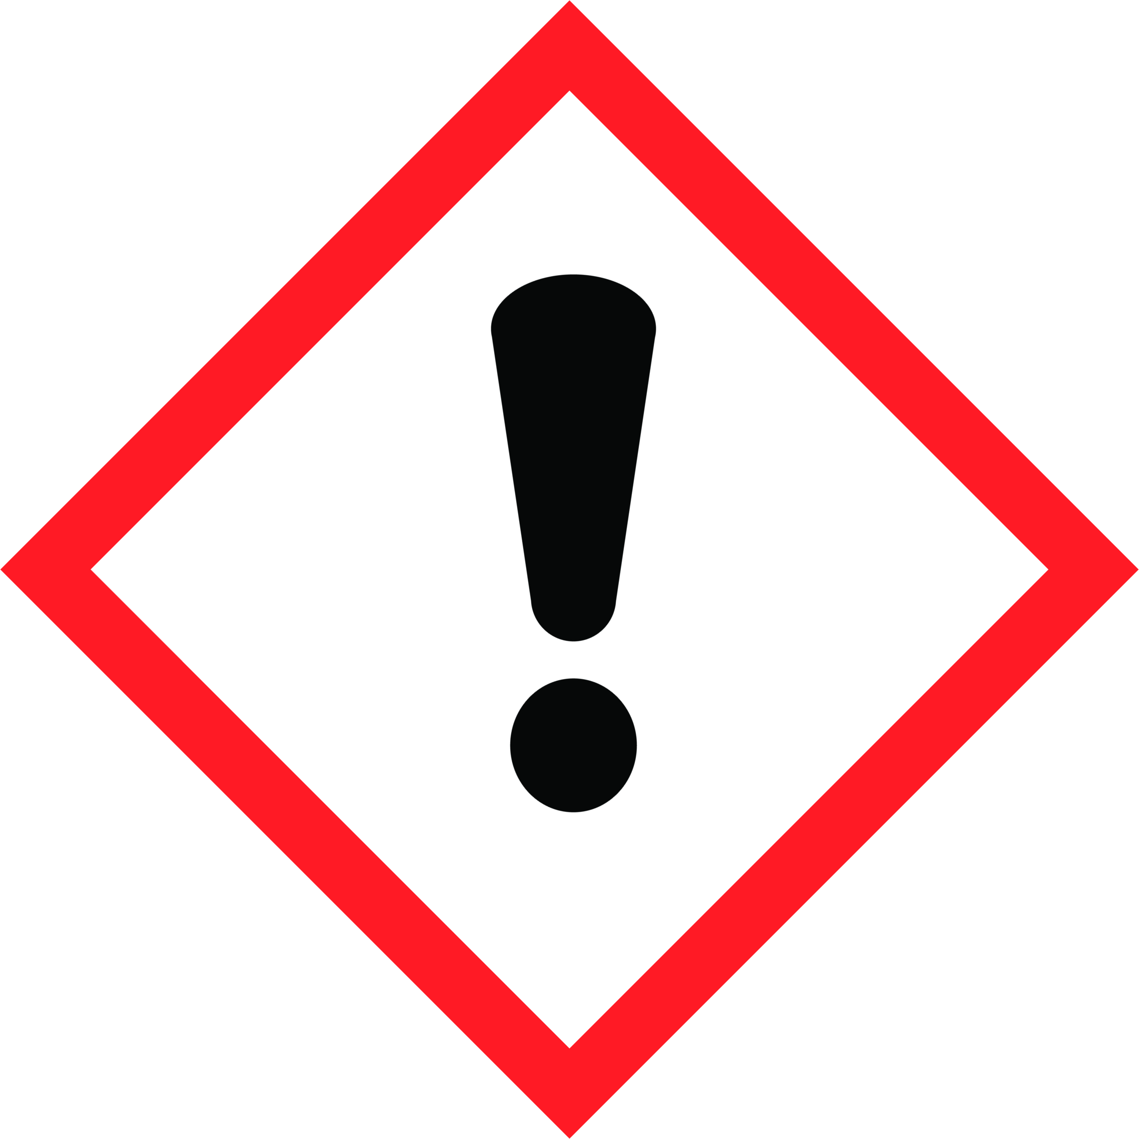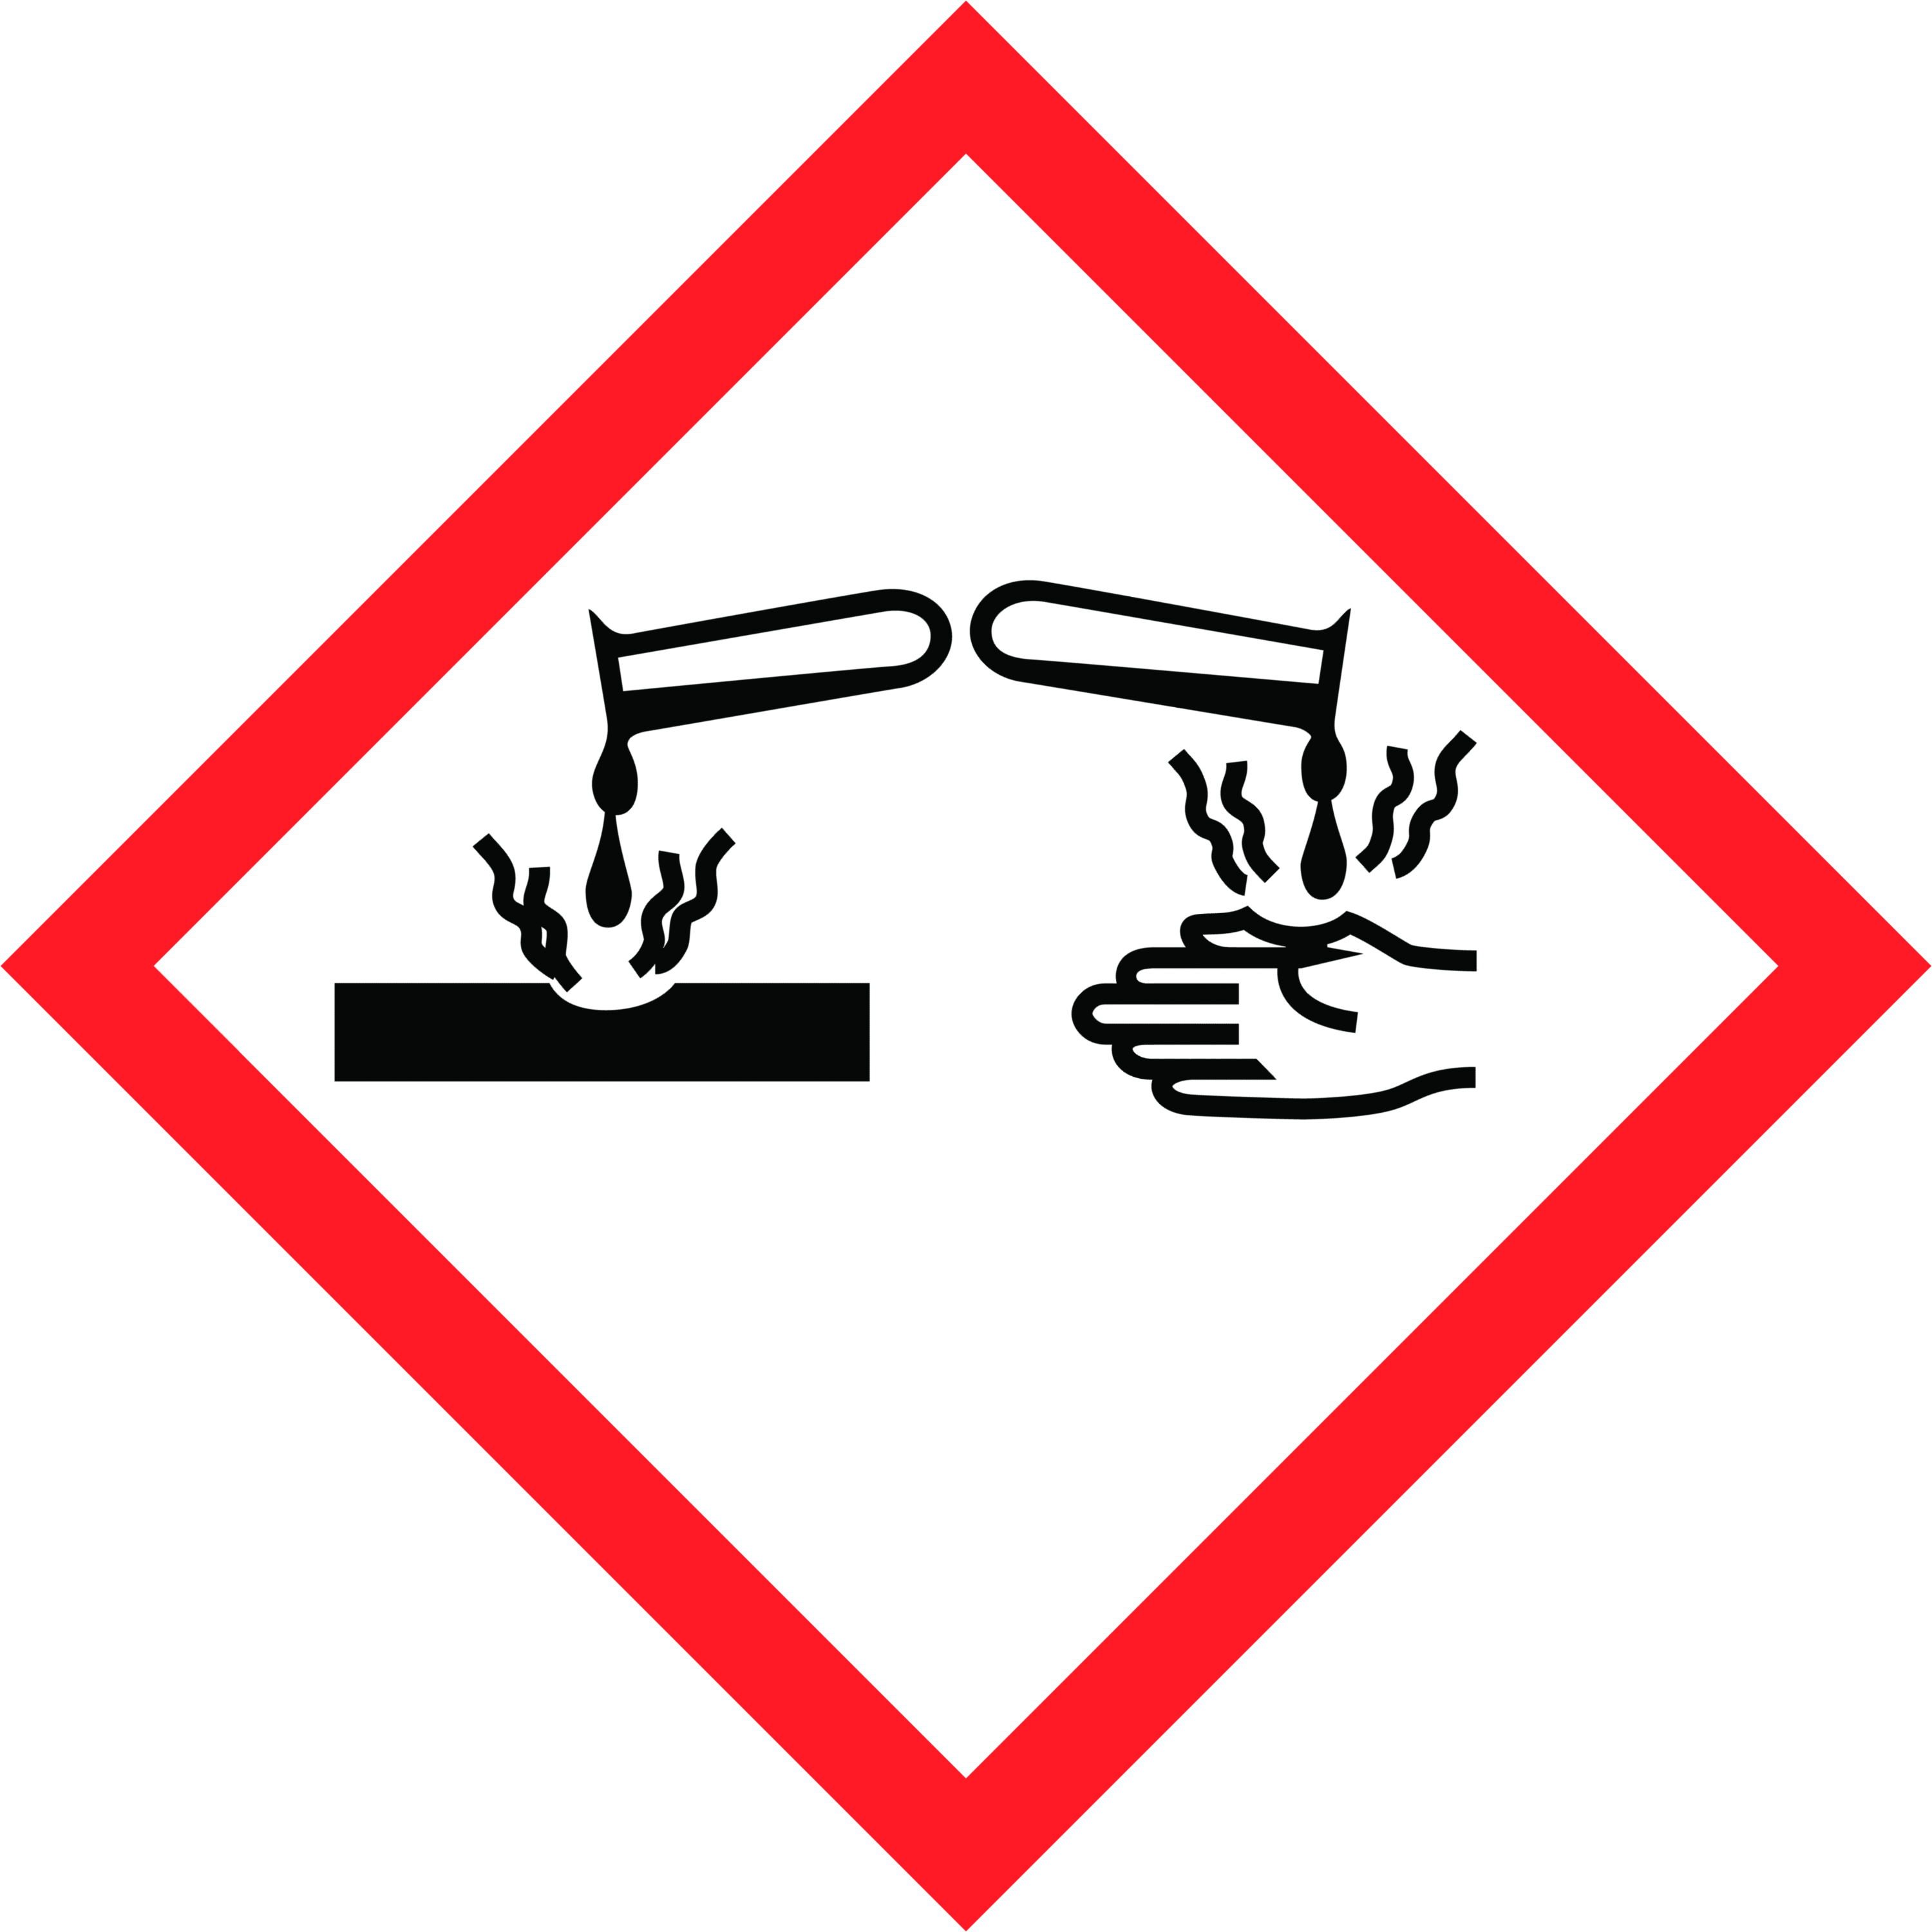  Safety Precautions  Personal Protective Equipment  - Wear disposable gloves while cleaning. Discard gloves after use. Wash hands frequently, before and after gloving with soap.  Equipment Required  - Non-scratch pad  - Microfiber cloths  - Spray bottle (Disinfectant)  - Toilet brush  - Mop/mop bucket  - Broom/dustpan  - Wet floor sign  Training Required  These chemicals are only to be used by staff who have received full training, which includes:  - Reviewing this safe operating procedure | - Workplace Hazardous Materials Information System (WHMIS)  - Reviewing the product label for usage information  - Hands-on training and sign-off on Training Acknowledgement Form  Operational Procedure  If visibly soiled, surface must be cleaned and rinsed before disinfection. Work top to bottom. Thoroughly wet surface with a registered disinfectant. Surface must remain wetted per  instructions for disinfection.  Frequency  - Twice a day  Procedure  - Place wet floor sign at entrance.  - Evaluate restroom and remove debris from floors and counters.  - Spray (and do not wipe) all bathroom hard surfaces with disinfectant cleaner—toilet, urinals, sinks, shower/tub, countertops and fixtures.  - Restock supplies and empty trash.  - Clean mirrors, glass and windows.  - Scrub toilet and urinals.  - Wipe bathroom hard surfaces and high touch points after required disinfectant contact time or allow surfaces to air dry.  - Clean and disinfectant floors and apply odor control product (as needed).  - Inspect for quality and remove floor sign when floor is dry.

Need More Information?
Refer to product label for usage information related to safety, PPE requirements, dilution and surface compatibility.
Refer to the Safety Data Sheets (SDS) for comprehensive information about product hazards and safety precautions.

