Safe Operating Procedure

High Frequency Touch Point Disinfection

Non-food Contact
Chemicals  Chemicals to be used while cleaning:  - ECOLAB Peroxide Multi Surface Cleaner and Disinfectant  - Dilution: 47 mL/L (6 fl. oz/gallon)  - Contact time: 1 minute  - Do not mix with bleach or other chlorinated products – will cause chlorine gas.  - ECOLAB Neutral Disinfectant Cleaner  - Dilution: 2 fl. oz/gallon  - Contact time: 10 minutes  HAZARDS  \  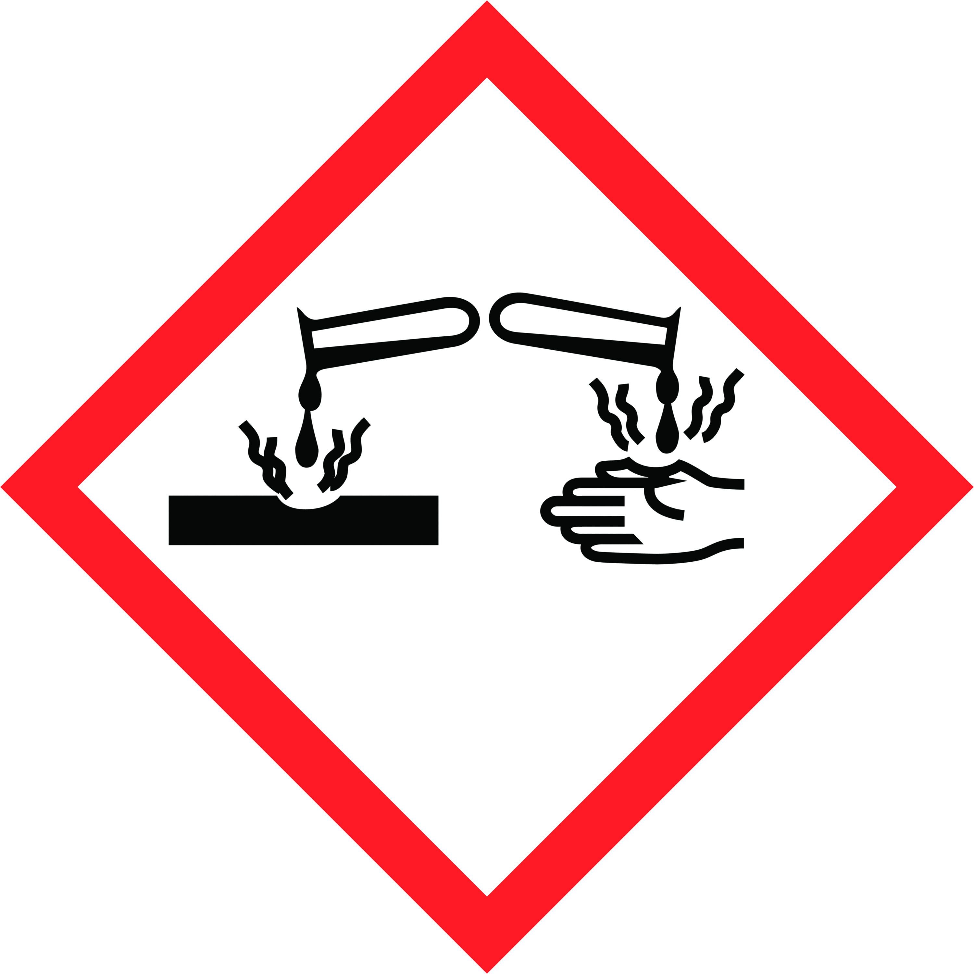  Safety Precautions  Personal Protective Equipment  - Wear disposable gloves while cleaning. Discard gloves after use. Wash hands frequently, before and after gloving with soap.  Equipment Required  - Microfiber cloths  - Spray bottle (Disinfectant)  Training Required  These chemicals are only to be used by staff who have received full training, which includes:  - Reviewing this safe operating procedure  - Workplace Hazardous Materials Information System (WHMIS) | - Reviewing the product label for usage information  - Hands-on training and sign-off on Training Acknowledgement Form  Operational Procedure  If visibly soiled, surface must be cleaned and rinsed before disinfection. Thoroughly wet surface with a registered disinfectant. Surface must remain wetted per instructions for disinfection.  Frequency  - Every 2 hours  Procedure  - Spray (and do not wipe) all high frequency touch points (such as: door handles, bathroom stalls (latch) fixtures, toilet and urinal handles, towel and soap dispensers, hand dryers, trash can, countertops, toilet paper dispensers, etc.).  - For any electronic device or control panel that needs to be disinfected, always spray the disinfectant onto a cloth and then wipe the device.  - Wipe touch points with microfiber cloth after required disinfectant contact time or allow surfaces to air dry.  - If food contact surface: sanitize with a registered food contact surface sanitizer and follow label directions for use.

Need More Information?
Refer to product label for usage information related to safety, PPE requirements, dilution and surface compatibility.
Refer to the Safety Data Sheets (SDS) for comprehensive information about product hazards and safety precautions.

