Safe Operating Procedure

Enhanced Turf Equipment Cleaning and Disinfection
Chemicals  Chemicals to be used while cleaning:  - Krown Power Kleen MP21  - Dilution: 40 ml/L (1:25)  - Contact time: 5 minutes  - ECOLAB Peroxide Multi Surface Cleaner and Disinfectant  - Dilution: 47 mL/L (6 fl. oz/gallon)  - Contact time: 1 minute  - Do not mix with chlorinated products (bleach) – will cause chlorine gas.  - ECOLAB Neutral Disinfectant Cleaner  Dilution: 2 fl. oz/gallon  Contact time: 10 minutes  HAZARDS  \  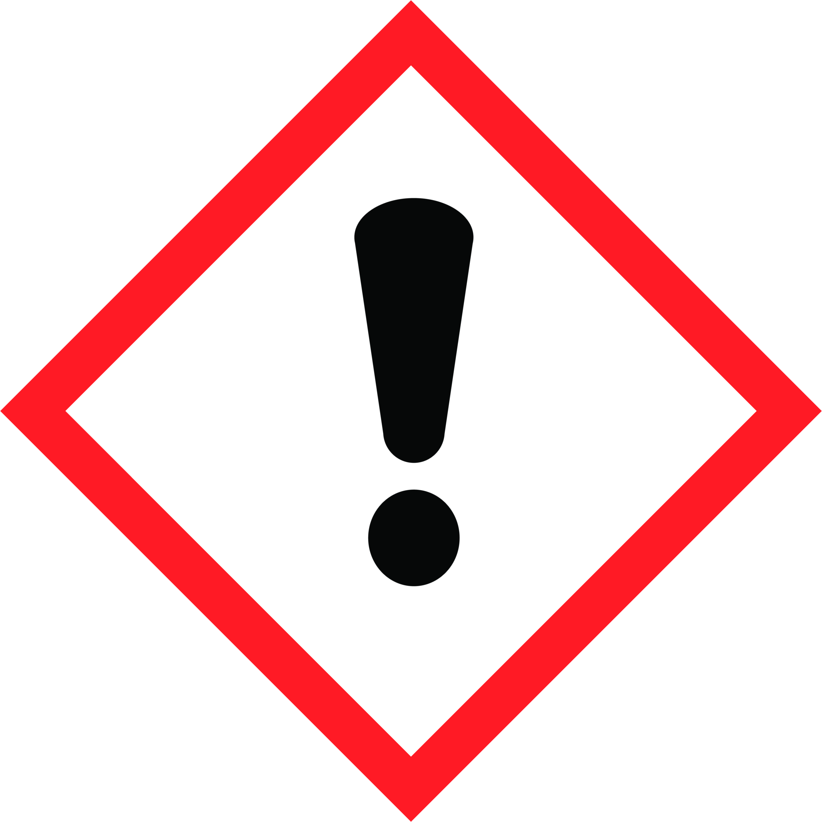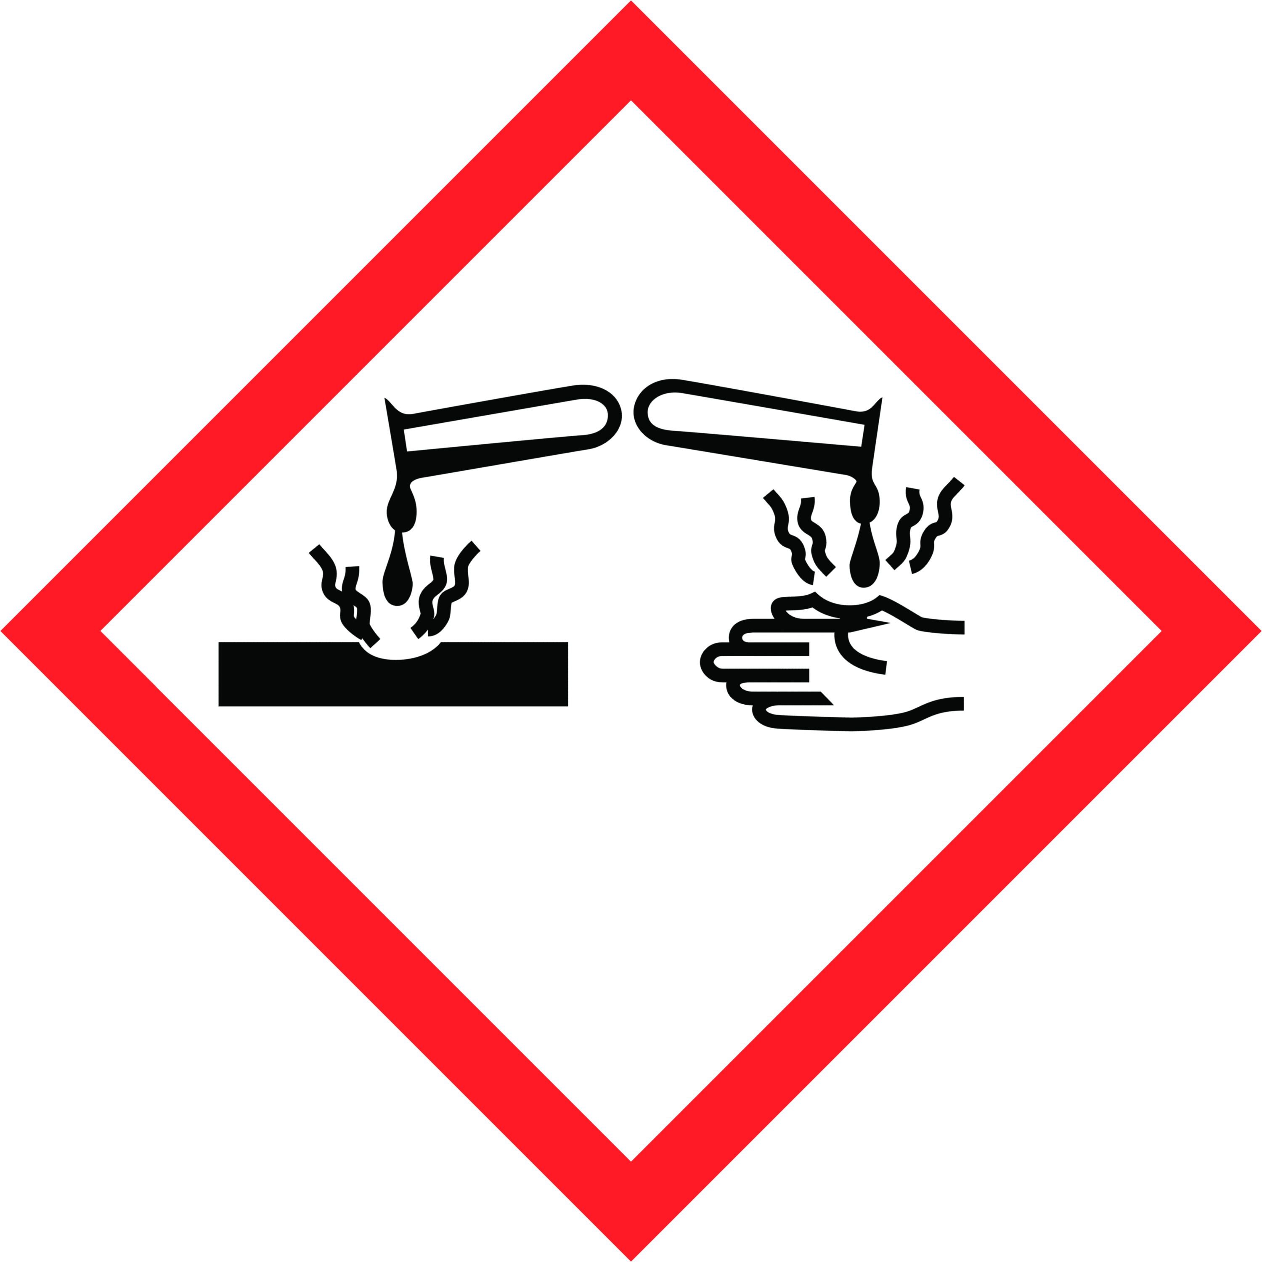  Safety Precautions  Personal Protective Equipment  - Wear disposable gloves while cleaning. Discard gloves after use. Wash hands frequently, before and after gloving with soap and/or hand sanitizer.  - Rain suit  - Face shield  Equipment Required  - Power washer  - Garden sprayer (Power Kleen MP21)  - Drying towels  - Spray bottle (Disinfectant)  - Microfiber cloths | Training Required  These chemicals are only to be used by staff who have received full training, which includes:  - Reviewing this safe operating procedure  - Workplace Hazardous Materials Information System (WHMIS)  - Reviewing the product label for usage information  - Hands-on training and sign-off on Training Acknowledgement Form  Operational Procedure  If visibly soiled, surface must be cleaned and rinsed before disinfection.  Frequency  - Daily (at the end of each day)  Cleaning Procedure  - Use garden sprayer to spray unit touch points with cleaner/degreaser solution (Power Kleen MP21).  - Leave the product to soak for 5 minutes.  - Use the high-volume water from the irrigation system hose to remove all grass clippings and debris.  - Use hot water power washer and rinse solution. Wrap the hose securely on the wall after use.  - Towel dry touch points.  - Fuel machine and park in storage facility.  Disinfecting Procedure  - Spray disinfectant (and do not wipe) on all touch points (such as: dashboard, key, steering wheel, seat, grab bars, switches…etc.).  - Wipe touch points with microfiber cloth after required disinfectant contact time or allow surfaces to air dry.  - Do not touch unit after this step.

Need More Information?
Refer to product label for usage information related to safety, PPE requirements, dilution and surface compatibility.
Refer to the Safety Data Sheets (SDS) for comprehensive information about product hazards and safety precautions.

