Safe Operating Procedure

Enhanced Hard Surface Disinfection
Chemicals  Chemicals to be used while cleaning:  - ECOLAB Scrub Free Bathroom Cleaner and Disinfectant  - Dilution: 4 fl. oz/gal  - Contact time: 5 minutes  - Do not mix with chlorinated products (bleach) – will cause chlorine gas.  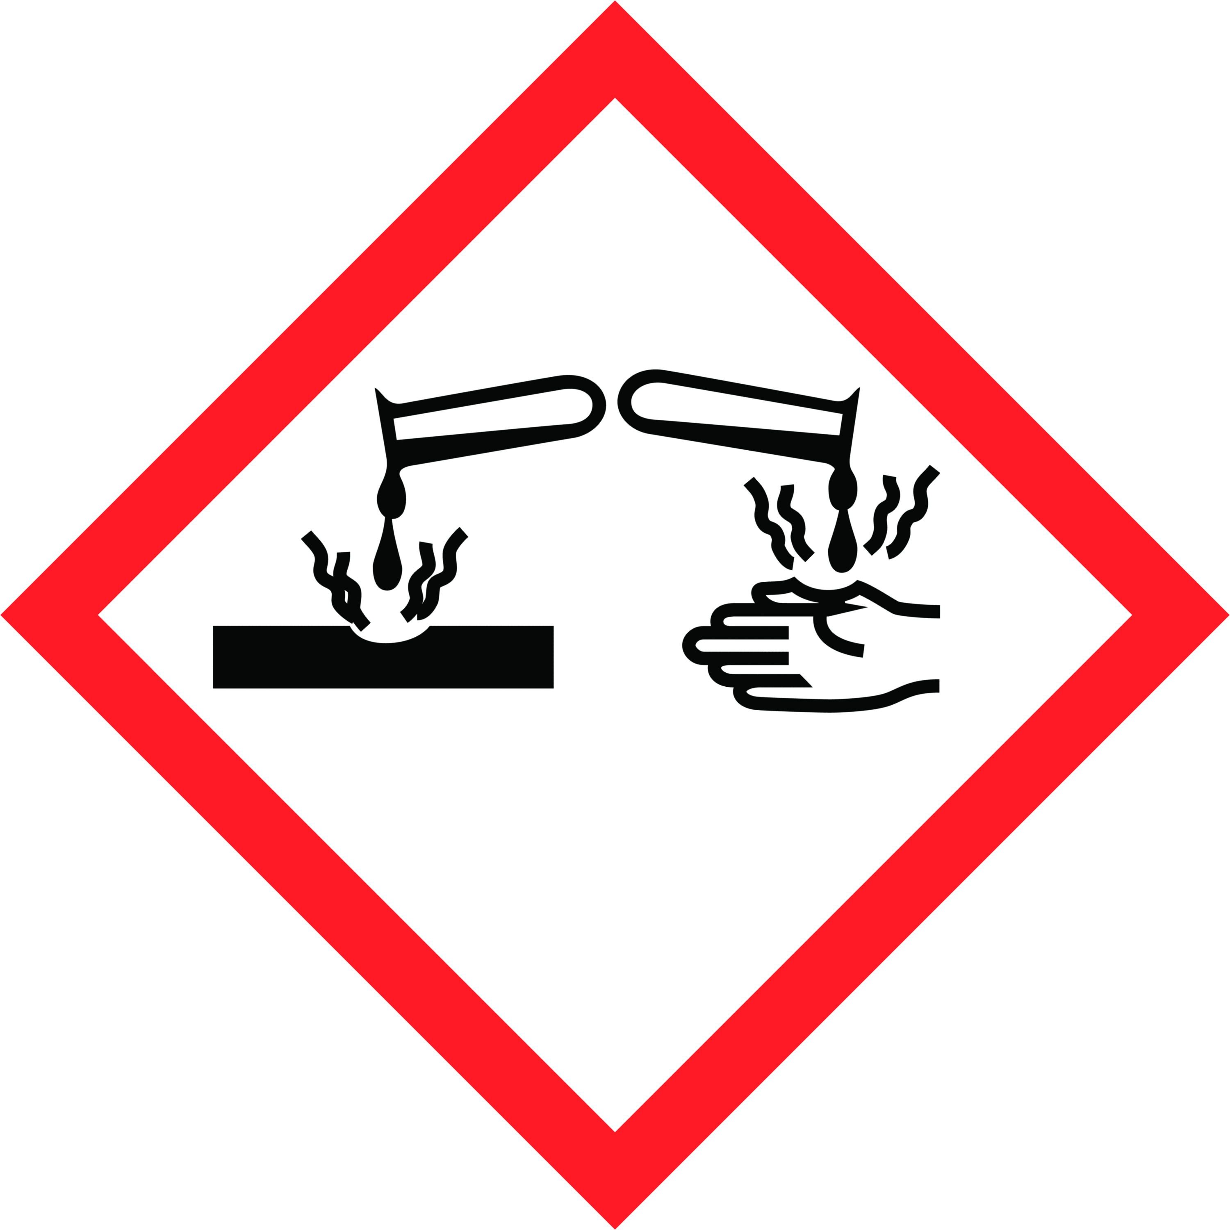  HAZARDS  \  Safety Precautions  Personal Protective Equipment  - Wear disposable gloves while cleaning. Discard gloves after use. Wash hands frequently, before and after gloving with soap.  - Face shield  Equipment Required  - Microfiber cloths  - Scrub Free Foamer Bottle  - Wet Floor Sign  Training Required  These chemicals are only to be used by staff who have received full training, which includes:  - Workplace Hazardous Materials Information System (WHMIS)  - Reviewing this safe operating procedure | - Reviewing the product label for usage information  - Hands-on training and sign-off on Training Acknowledgement Form  Operational Procedure  If visibly soiled, surface must be cleaned and rinsed before disinfection. Work top to bottom. Thoroughly wet surface with a registered disinfectant. Surface must remain wetted per instructions for disinfection.  Frequency:  - Twice a day  Procedure:  - Place wet floor sign at entrance.  - Surface must be cleaned and rinsed before disinfection.  - Only apply to hard, non-porous surfaces.  - Thoroughly wet surfaces with a sprayer or pump-up sprayer.  - All surfaces must remain wet for 5 minutes.  - Wipe surfaces with damp cloth.  - Inspect for quality and remove floor sign when floor is dry.

Need More Information?
Refer to product label for usage information related to safety, PPE requirements, dilution and surface compatibility.
Refer to the Safety Data Sheets (SDS) for comprehensive information about product hazards and safety precautions.

