Safe Operating Procedure

Enhanced Golf Cart Cleaning and Disinfection
Chemicals  Chemicals to be used while cleaning:  - Krown Power Kleen MP21  - Dilution: 40 ml/L (1:25)  - Contact time: 5 minutes  - ECOLAB Peroxide Multi Surface Cleaner and Disinfectant  - Dilution: 6 fl. oz/gallon  - Contact time: 1 minute  - Do not mix with chlorinated products (bleach) – will cause chlorine gas.  - ECOLAB Neutral Disinfectant Cleaner  - Dilution: 2 fl. oz/gallon  - Contact time: 10 minutes  HAZARDS  \  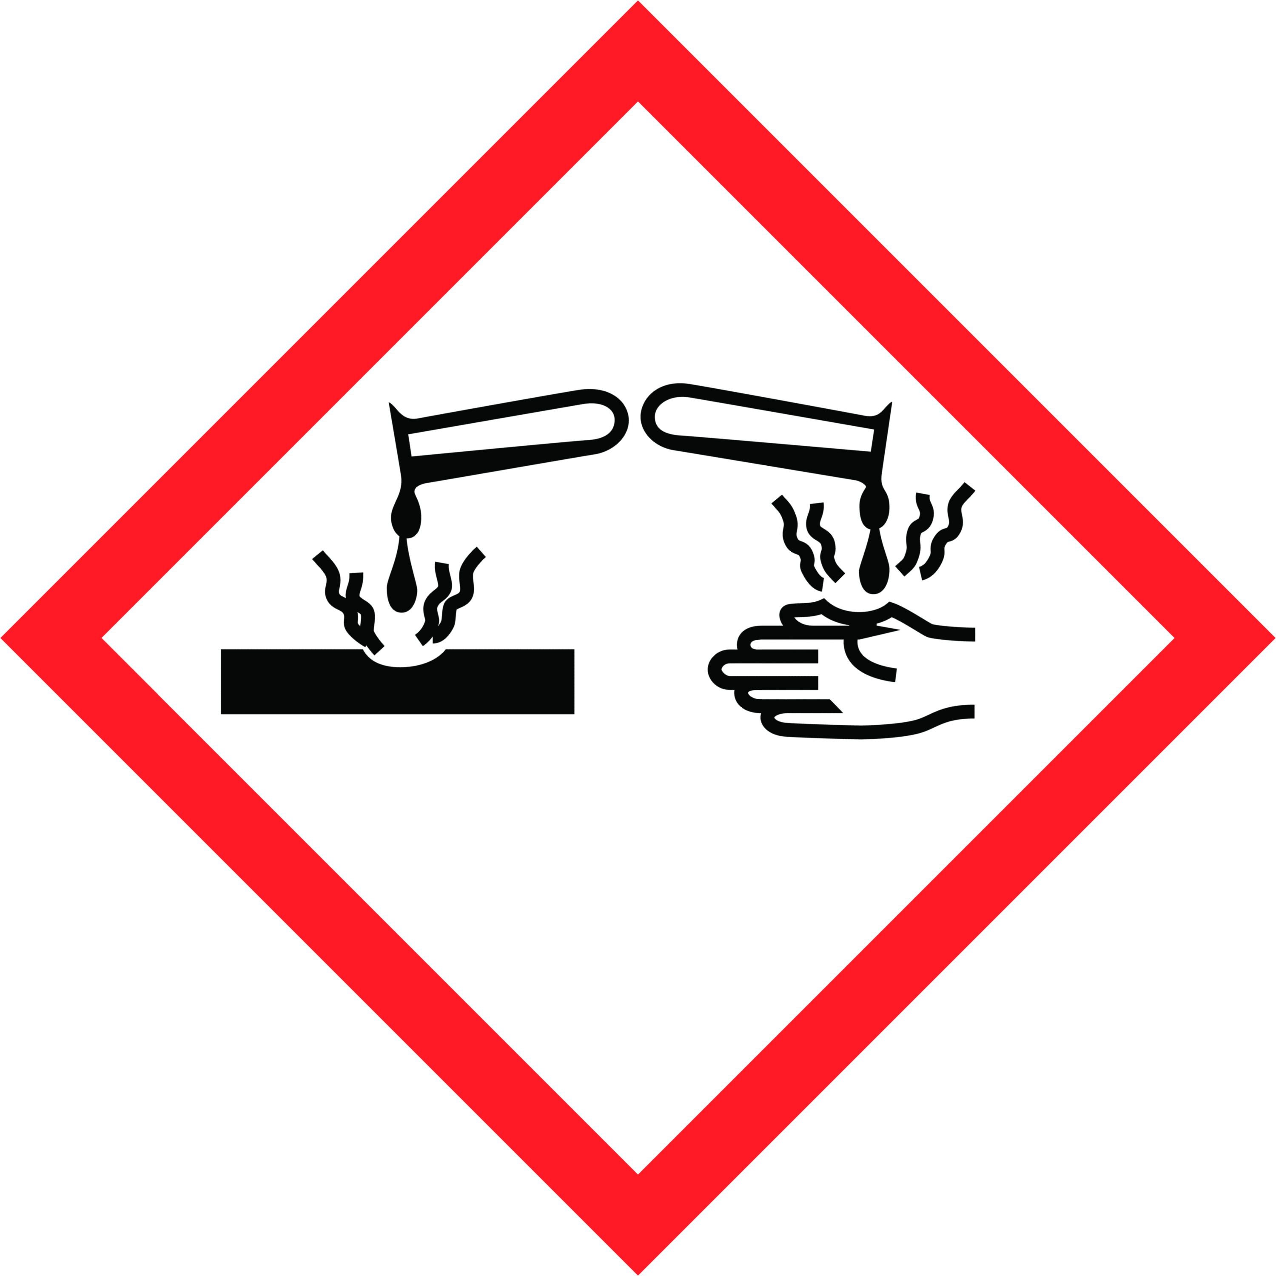  Safety Precautions  Personal Protective Equipment  - Wear disposable gloves while cleaning. Discard gloves after use. Wash hands frequently, before and after gloving with soap and/or hand sanitizer.  - Face shield  Equipment Required  - Garbage and recycling containers  - Power washer  - Garden sprayer (Power Kleen MP21)  - Drying towels  - Spray bottle (Disinfectant)  - Microfiber cloths  Training Required  These chemicals are only to be used by staff who have received full training, which includes:  - Reviewing this safe operating procedure | - Workplace Hazardous Materials Information System (WHMIS)  - Reviewing the product label for usage information  - Hands-on training and sign-off on Training Acknowledgement Form  Operational Procedure  Cleaning Procedure  - Tow cart to designated washing area.  - Remove all garbage and debris from cart and place into garbage and recycling.  - Use garden sprayer to spray entire cart with cleaner/degreaser solution (Power Kleen MP21).  - Leave the product to soak for 5 minutes.  - Use hot water power washer and spray entire cart to rinse solution. Wrap the hose securely on the wall after use.  - Towel dry cowlings, seats, dash to remove water marks.  - Park in storage facility and connect charger.  Disinfecting Procedure  - Spray disinfectant (and do not wipe) on all touch points (such as: dashboard, key, cubby holes, cup holders, steering wheel, seat, windshield, grab bars, bag straps…etc.).  - Wipe touch points with microfiber cloth after required disinfectant contact time or allow surfaces to air dry.  - Do not touch the golf cart after this step.  Staging Procedure  - Drive cart to staging area.  - Place name of golfer(s) on cart.  - When cart is in place follow above disinfecting procedure.

Need More Information?
Refer to product label for usage information related to safety, PPE requirements, dilution and surface compatibility.
Refer to the Safety Data Sheets (SDS) for comprehensive information about product hazards and safety precautions.

